**ADDING TEXT ON PHOTOSHOP**

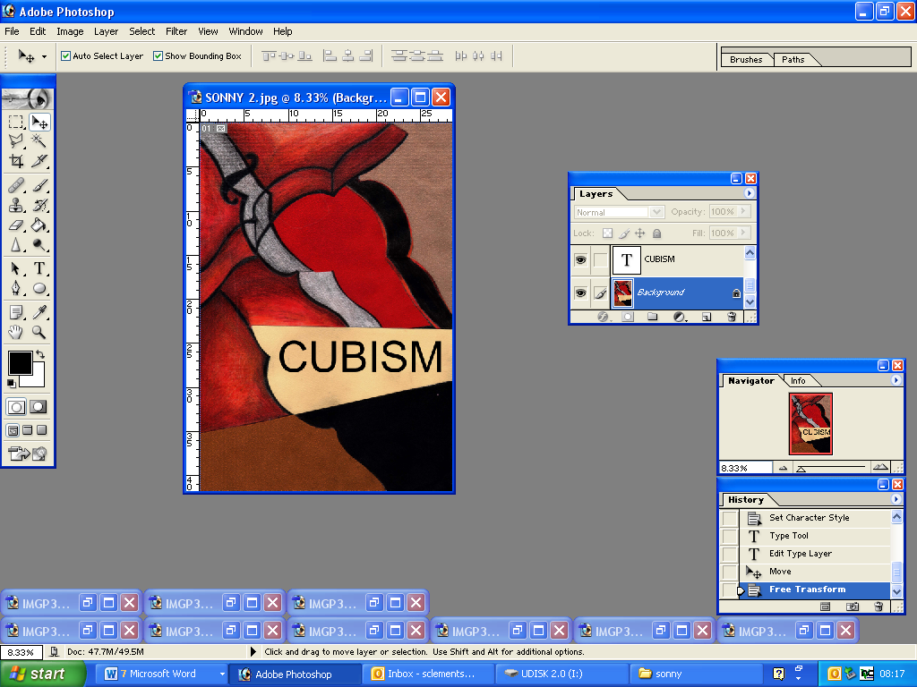

Click on ‘T’ to add text to your design

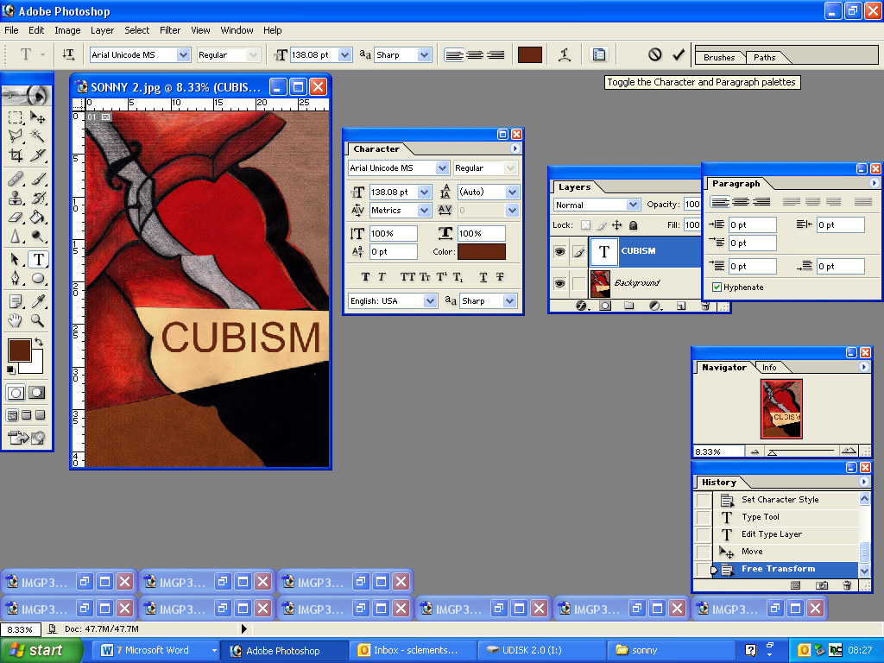

Click on this box to change colour, scale, space between each letter

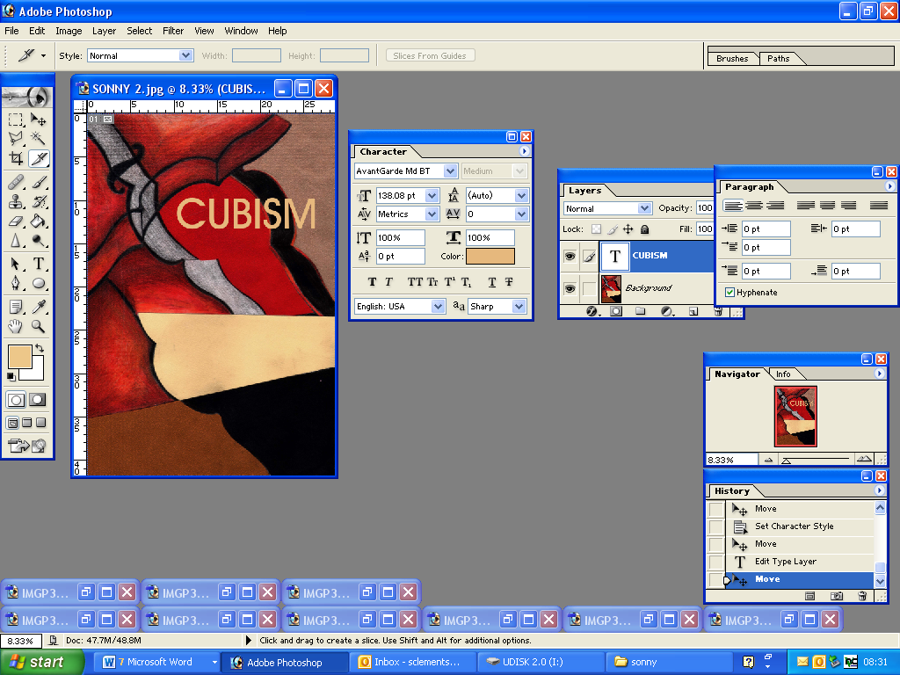

Click on move tool to move text.

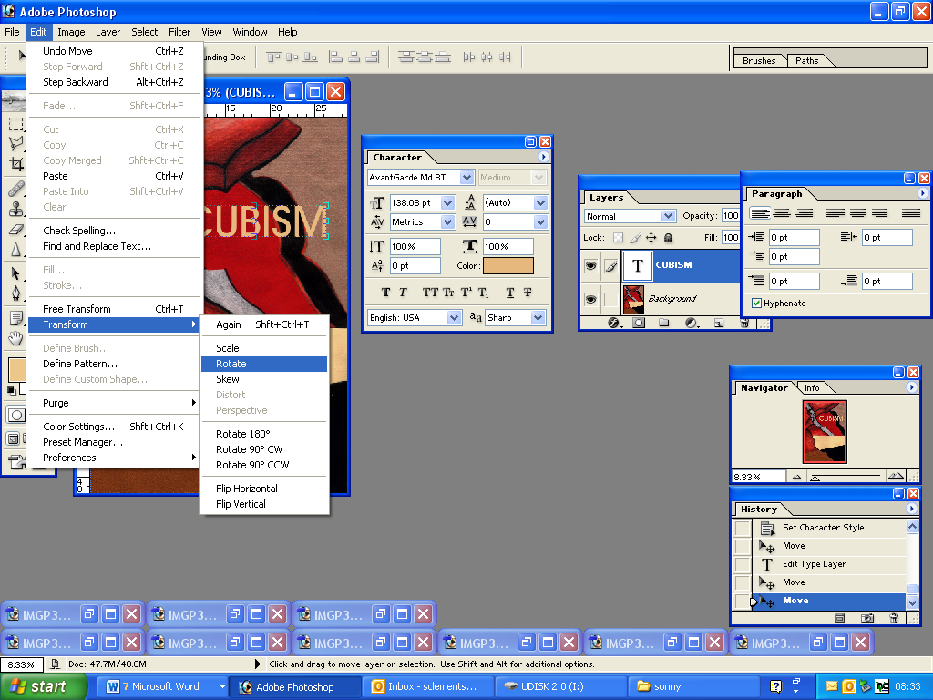

Go to **EDIT – TRANSFORM – ROTATE**

**To rotate your text**

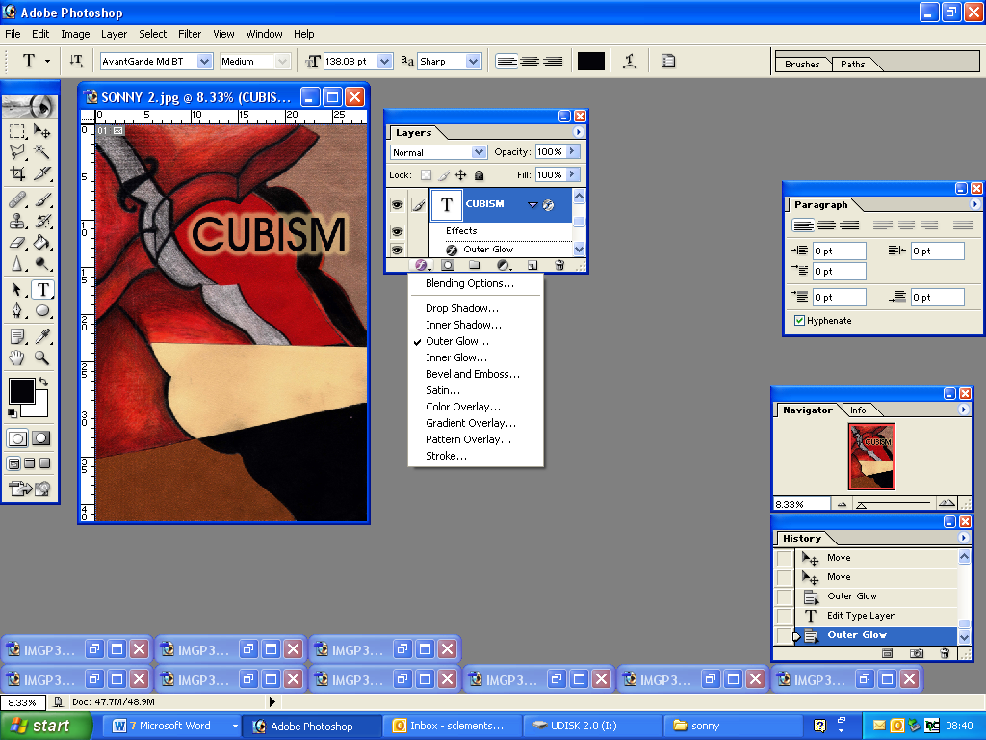

Click on ‘F’ at the bottom of LAYERS BOX to add outlines and outer glows

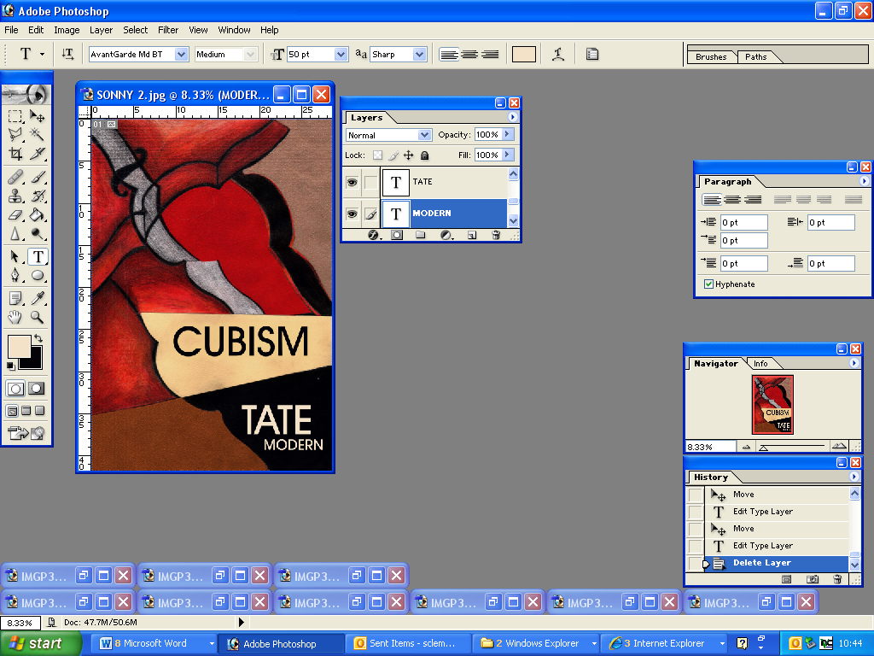

When you are adding TATE MODERN

Make sure each word is on a different layer so you can position them where you want.